**ZUUL PROJECT DEMONSTRATION**

Before you start, ensure that some needed packages are installed.

***# Ubuntu / Debian:***

**sudo apt-get update**

**sudo apt-get install docker-compose docker.io git python3-pip**

**sudo python3 -m pip install git-review**

***# Start and Enable the docker service on Fedora / CentOS***

***# Red Hat / OpenSuse / Ubuntu / Debian:***

**sudo systemctl enable docker.service**

**sudo systemctl start docker.service**

Clone the Zuul repository:

**git clone https://opendev.org/zuul/zuul**

Then cd into the directory containing this document, and run docker-compose in order to start Zuul, Nodepool and Gerrit.

**cd zuul/doc/source/examples**

**sudo -E docker-compose -p zuul-tutorial up**

For reference, the files in that directory are also [browsable on the web](https://opendev.org/zuul/zuul/src/branch/master/doc/source/examples).

All of the services will be started with debug-level logging sent to the standard output of the terminal where docker-compose is running. You will see a considerable amount of information scroll by, including some errors. Zuul will immediately attempt to connect to Gerrit and begin processing, even before Gerrit has fully initialized. The docker composition includes scripts to configure Gerrit and create an account for Zuul. Once this has all completed, the system should automatically connect, stabilize and become idle. When this is complete, you will have the following services running:

* Zookeeper
* Gerrit
* Nodepool Launcher
* Zuul Scheduler
* Zuul Web Server
* Zuul Executor
* Apache HTTPD

And a long-running static test node used by Nodepool and Zuul upon which to run tests.

The Zuul scheduler is configured to connect to Gerrit via a connection named gerrit. Zuul can interact with as many systems as necessary, each such connection is assigned a name for use in the Zuul configuration.

Zuul is a multi-tenant application, so that differing needs of independent work-groups can be supported from one system. This example configures a single tenant named example-tenant. Assigned to this tenant are three projects: zuul-config, test1 and test2. These have already been created in Gerrit and are ready for us to begin using.

**Add Your Gerrit Account**

Before you can interact with Gerrit, you will need to create an account. The initialization script has already created an account for Zuul, but has left the task of creating your own account to you so that you can provide your own SSH key. You may safely use any existing SSH key on your workstation, or you may create a new one by running ssh-keygen.

Gerrit is configured in a development mode where passwords are not required in the web interface and you may become any user in the system at any time.

To create your Gerrit account, visit [http://localhost:8080](http://localhost:8080/) in your browser and click *Sign in* in the top right corner.

The click *New Account* under *Register*.

Don’t bother to enter anything into the confirmation dialog that pops up, instead, click the *settings* link at the bottom.

In the *Profile* section at the top, enter the username you use to log into your workstation in the *Username* field and your full name in the *Full name* field, then click *Save Changes*.

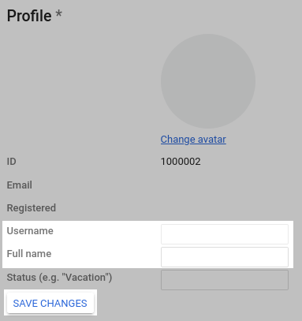

Scroll down to the *Email Addresses* section and enter your email address into the *New email address* field, then click *Send Verification*. Since Gerrit is in developer mode, it will not actually send any email, and the address will be automatically confirmed. This step is useful since several parts of the Gerrit user interface expect to be able to display email addresses.

Scroll down to the *SSH keys* section and copy and paste the contents of ~/.ssh/id_rsa.pub into the *New SSH key* field and click *Add New SSH Key*.

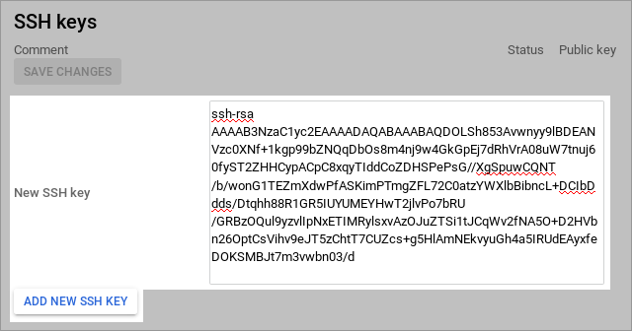

Click the *Reload* button in your browser to reload the page with the new settings in effect. At this point you have created and logged into your personal account in Gerrit and are ready to begin configuring Zuul.

**Configure Zuul Pipelines**

Zuul recognizes two types of projects: [config projects](https://zuul-ci.org/docs/zuul/4.11.0/reference/glossary.html#term-config-project) and [untrusted projects](https://zuul-ci.org/docs/zuul/4.11.0/reference/glossary.html#term-untrusted-project). An *untrusted project* is a normal project from Zuul’s point of view. In a gating system, it contains the software under development and/or most of the job content that Zuul will run. A *config project* is a special project that contains the Zuul’s configuration. Because it has access to normally restricted features in Zuul, changes to this repository are not dynamically evaluated by Zuul. The security and functionality of the rest of the system depends on this repository, so it is best to limit what is contained within it to the minimum, and ensure thorough code review practices when changes are made.

Zuul has no built-in workflow definitions, so in order for it to do anything, you will need to begin by making changes to a *config project*. The initialization script has already created a project named zuul-config which you should now clone onto your workstation:

**git clone http://localhost:8080/****zuul-config**

You will find that this repository is empty. Zuul reads its configuration from either a single file or a directory. In a *Config Project* with substantial Zuul configuration, you may find it easiest to use the zuul.d directory for Zuul configuration. Later, in *Untrusted Projects* you will use a single file for in-repo configuration. Make the directory:

**cd zuul-config**

**mkdir zuul.d**

The first type of configuration items we need to add are the Pipelines we intend to use. In Zuul, a Pipeline represents a workflow action. It is triggered by some action on a connection. Projects are able to attach jobs to run in that pipeline, and when they complete, the results are reported along with actions which may trigger further Pipelines. In a gating system two pipelines are required: [check](https://zuul-ci.org/docs/zuul/4.11.0/reference/glossary.html#term-check) and [gate](https://zuul-ci.org/docs/zuul/4.11.0/reference/glossary.html#term-gate). In our system, check will be triggered when a patch is uploaded to Gerrit, so that we are able to immediately run tests and report whether the change works and is therefore able to merge. The gate pipeline is triggered when a code reviewer approves the change in Gerrit. It will run test jobs again (in case other changes have merged since the change in question was uploaded) and if these final tests pass, will automatically merge the change. To configure these pipelines, copy the following file into *zuul.d/pipelines.yaml*:

**- pipeline:**

**name: check**

**description: |**

**Newly uploaded patchsets enter this pipeline to receive an**

**initial +/-1 Verified vote.**

**manager: independent**

**require:**

**gerrit:**

**open: True**

**current-patchset: True**

**trigger:**

**gerrit:**

**- event: patchset-created**

**- event: change-restored**

**- event: comment-added**

**comment: (?i)^(Patch Set [0-9]+:)?( [\w\\+-]*)*(\n\n)?\s*recheck**

**success:**

**gerrit:**

**Verified: 1**

**failure:**

**gerrit:**

**Verified: -1**

**- pipeline:**

**name: gate**

**description: |**

**Changes that have been approved are enqueued in order in this**

**pipeline, and if they pass tests, will be merged.**

**manager: dependent**

**post-review: True**

**require:**

**gerrit:**

**open: True**

**current-patchset: True**

**approval:**

**- Workflow: 1**

**trigger:**

**gerrit:**

**- event: comment-added**

**approval:**

**- Workflow: 1**

**start:**

**gerrit:**

**Verified: 0**

**success:**

**gerrit:**

**Verified: 2**

**submit: true**

**failure:**

**gerrit:**

**Verified: -2**

Once we have bootstrapped our initial Zuul configuration, we will want to use the gating process on this repository too, so we need to attach the zuul-config repository to the check and gate pipelines we are about to create. There are no jobs defined yet, so we must use the internally defined noop job, which always returns success. Later on we will be configuring some other projects, and while we will be able to dynamically add jobs to their pipelines, those projects must first be attached to the pipelines in order for that to work. In our system, we want all of the projects in Gerrit to participate in the check and gate pipelines, so we can use a regular expression to apply this to all projects. To configure the check and gate pipelines for zuul-config to run the noop job, and add all projects to those pipelines (with no jobs), copy the following file into zuul.d/projects.yaml:

**- project:**

**name: ^.*$**

**check:**

**jobs: []**

**gate:**

**jobs: []**

**- project:**

**name: zuul-config**

**check:**

**jobs:**

**- noop**

**gate:**

**jobs:**

**- noop**

Every real job (i.e., all jobs other than noop) must inherit from a [base job](https://zuul-ci.org/docs/zuul/4.11.0/reference/glossary.html#term-base-job), and base jobs may only be defined in a [config-project](https://zuul-ci.org/docs/zuul/4.11.0/reference/glossary.html#term-config-project). Let’s go ahead and add a simple base job that we can build on later. Copy the following into zuul.d/jobs.yaml:

**- job:**

**name: base**

**parent: null**

**nodeset:**

**nodes:**

**- name: ubuntu-focal**

**label: ubuntu-focal**

Commit the changes and push them up for review:

**git add zuul.d**

**git commit -m "Add initial Zuul configuration"**

**git review**

Because Zuul is currently running with no configuration whatsoever, it will ignore this change. For this initial change which bootstraps the entire system, we will need to bypass code review (hopefully for the last time). To do this, you need to switch to the Administrator account in Gerrit. Visit [http://localhost:8080](http://localhost:8080/) in your browser and then:

Click the avatar image in the top right corner then click *Sign out*.

Then click the *Sign in* link again.

Click *admin* to log in as the *admin* user.

You will then see a list of open changes; click on the change you uploaded.

Click *Reply…* at the top center of the change screen. This will open a dialog where you can leave a review message and vote on the change. As the administrator, you have access to vote in all of the review categories, even *Verified* which is normally reserved for Zuul. Vote Code-Review: +2, Verified: +2, Workflow: +1, and then click *Send* to leave your approval votes.

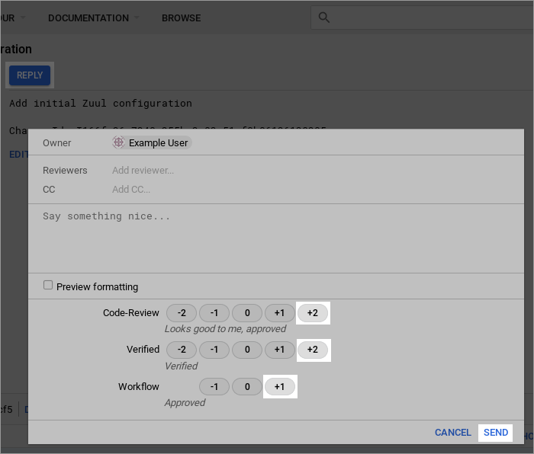

Once the required votes have been set, the *Submit* button will appear in the top right; click it. This will cause the change to be merged immediately. This is normally handled by Zuul, but as the administrator you can bypass Zuul to forcibly merge a change.

Now that the initial configuration has been bootstrapped, you should not need to bypass testing and code review again, so switch back to the account you created for yourself. Click on the avatar image in the top right corner then click *Sign out*.

Then click the *Sign in* link again.

And click your username to log into your account.

**Test Zuul Pipelines**

Zuul is now running with a basic [check](https://zuul-ci.org/docs/zuul/4.11.0/reference/glossary.html#term-check) and [gate](https://zuul-ci.org/docs/zuul/4.11.0/reference/glossary.html#term-gate) configuration. Now is a good time to take a look at Zuul’s web interface. Visit <http://localhost:9000/t/example-tenant/status> to see the current status of the system. It should be idle, but if you leave this page open during the following steps, you will see it update automatically.

We can now begin adding Zuul configuration to one of our [untrusted projects](https://zuul-ci.org/docs/zuul/4.11.0/reference/glossary.html#term-untrusted-project). Start by cloning the *test1* project which was created by the setup script.

**cd ..**

**git clone http://localhost:8080/test1**

Every Zuul job that runs needs a playbook, so let’s create a sub-directory in the project to hold playbooks:

**cd test1**

**mkdir playbooks**

Start with a simple playbook which just outputs a debug message. Copy the following to playbooks/testjob.yaml:

**- hosts: all**

**tasks:**

**- debug:**

**msg: Hello world!**

Now define a Zuul job which runs that playbook. Zuul will read its configuration from any of zuul.d/ or .zuul.d/ directories, or the files zuul.yaml or .zuul.yaml. Generally in an *untrusted project* which isn’t dedicated entirely to Zuul, it’s best to put Zuul’s configuration in a hidden file. Copy the following to .zuul.yaml in the root of the project:

**- job:**

**name: testjob**

**run: playbooks/testjob.yaml**

**- project:**

**check:**

**jobs:**

**- testjob**

**gate:**

**jobs:**

**- testjob**

Commit the changes and push them up to Gerrit for review:

**git add .zuul.yaml playbooks**

**git commit -m "Add test Zuul job"**

**git review**

Zuul will dynamically evaluate proposed changes to its configuration in *untrusted projects* immediately, so shortly after your change is uploaded, Zuul will run the new job and report back on the change.

Visit <http://localhost:8080/dashboard/self> and open the change you just uploaded. If the build is complete, Zuul should have left a Verified: +1 vote on the change, along with a comment at the bottom. Expand the comments and you should see that the job succeeded, and a link to the build result in Zuul is provided. You can follow that link to see some information about the build, but you won’t find any logs since Zuul hasn’t been told where to save them yet.

This means everything is working so far, but we need to configure a bit more before we have a useful job.

**Configure a Base Job**

Every Zuul tenant needs at least one base job. Zuul administrators can use a base job to customize Zuul to the local environment. This may include tasks which run both before jobs, such as setting up package mirrors or networking configuration, or after jobs, such as artifact and log storage.

Zuul doesn’t take anything for granted, and even tasks such as copying the git repos for the project being tested onto the remote node must be explicitly added to a base job (and can therefore be customized as needed). The Zuul in this tutorial is pre-configured to use the [zuul jobs](https://zuul-ci.org/docs/zuul-jobs/) repository which is the “standard library” of Zuul jobs and roles. We will make use of it to quickly create a base job which performs the necessary set up actions and stores build logs.

Return to the zuul-config repo that you were working in earlier. We’re going to add some playbooks to the empty base job we created earlier. Start by creating a directory to store those playbooks:

**cd ..**

**cd zuul-config**

**mkdir -p playbooks/base**

Zuul supports running any number of playbooks before a job (called *pre-run* playbooks) or after a job (called *post-run* playbooks). We’re going to add a single *pre-run* playbook now. Copy the following to playbooks/base/pre.yaml:

**- hosts: all**

**roles:**

**- add-build-sshkey**

**- prepare-workspace**

This playbook does two things; first it creates a new SSH key and adds it to all of the hosts in the inventory, and removes the private key that Zuul normally uses to log into nodes from the running SSH agent. This is just an extra bit of protection which ensures that if Zuul’s SSH key has access to any important systems, normal Zuul jobs can’t use it. The second thing the playbook does is copy the git repositories that Zuul has prepared (which may have one or more changes being tested) to all of the nodes used in the job.

Next, add a *post-run* playbook to remove the per-build SSH key. Copy the following to playbooks/base/post-ssh.yaml:

**- hosts: all**

**roles:**

**- remove-build-sshkey**

This is the complement of the *add-build-sshkey* role in the pre-run playbook – it simply removes the per-build ssh key from any remote systems. Zuul always tries to run all of the post-run playbooks regardless of whether any previous playbooks have failed. Because we always want log collection to run and we want it to run last, we create a second post-run playbook for it. Copy the following to playbooks/base/post-logs.yaml:

**- hosts: localhost**

**gather_facts: False**

**roles:**

**- generate-zuul-manifest**

**- role: upload-logs**

**zuul_log_url: "http://localhost:8000"**

The first role in this playbook generates some metadata about the logs which are about to be uploaded. Zuul uses this metadata in its web interface to nicely render the logs and other information about the build.

This tutorial is running an Apache webserver in a container which will serve build logs from a volume that is shared with the Zuul executor. That volume is mounted at */srv/static/logs*, which is the default location in the [upload-logs](https://zuul-ci.org/docs/zuul-jobs/roles.html#role-upload-logs) role. The role also supports copying files to a remote server via SCP; see the role documentation for how to configure it. For this simple case, the only option we need to provide is the URL where the logs can ultimately be found.

Now that the new playbooks are in place, update the base job definition to include them. Overwrite zuul.d/jobs.yaml with the following:

**- job:**

**name: base**

**parent: null**

**description: |**

**The recommended base job.**

**All jobs ultimately inherit from this. It runs a pre-playbook**

**which copies all of the job's prepared git repos on to all of**

**the nodes in the nodeset.**

**It also sets a default timeout value (which may be overidden).**

**pre-run: playbooks/base/pre.yaml**

**post-run:**

**- playbooks/base/post-ssh.yaml**

**- playbooks/base/post-logs.yaml**

**roles:**

**- zuul: zuul/zuul-jobs**

**timeout: 1800**

**nodeset:**

**nodes:**

**- name: ubuntu-focal**

**label: ubuntu-focal**

Then commit the change and upload it to Gerrit for review:

**git add playbooks zuul.d/jobs.yaml**

**git commit -m "Update Zuul base job"**

**git review**

Visit <http://localhost:8080/dashboard/self> and open the zuul-config change you just uploaded.

You should see a Verified +1 vote from Zuul. Click *Reply* then vote Code-Review: +2 and Workflow: +1 then click *Send*.

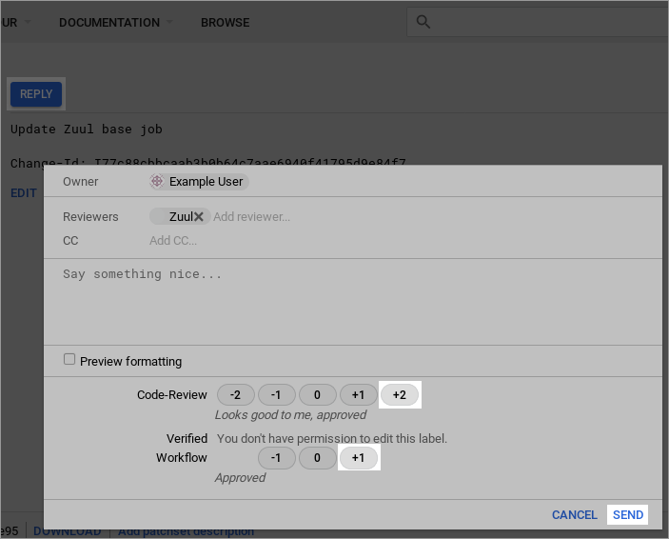

Wait a few moments for Zuul to process the event, and then reload the page. The change should have been merged.

Visit <http://localhost:8080/dashboard/self> and return to the test1 change you uploaded earlier. Click *Reply* then type *recheck* into the text field and click *Send*.

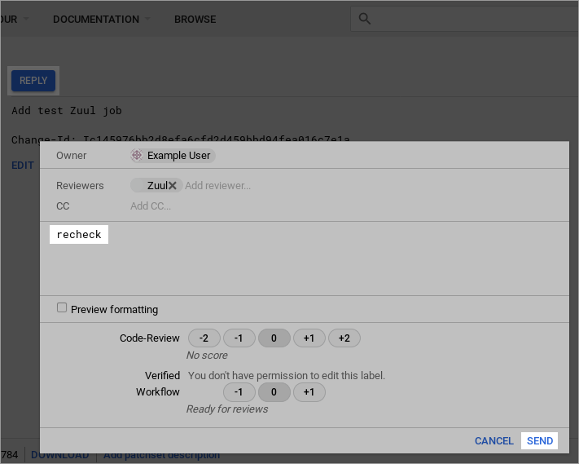

This will cause Zuul to re-run the test job we created earlier. This time it will run with the updated base job configuration, and when complete, it will report the published log location as a comment on the change:

Follow the link and you will be directed to the build result page. If you click on the *Logs* tab, you’ll be able to browse the console log for the job. In the middle of the log, you should see the “Hello, world!” output from the job’s playbook.

Also try the *Console* tab for a more structured view of the log. Click on the *OK* button in the middle of the page to see the output of just the task we’re interested in.